## AUTOMATIC TICKET ISSUING SYSTEM

## CLASS DIAGRAM

In our class diagram, its clear that we have 3 main classes, Passenger, Ticket and Credit card class. These are the main classes which handles the whole operation of the system as stated on how system operates in the description.

Passenger class represents the customers at who wants to travel, it holds all their relevant information to the system. Ticket class hold the Passenger details including the passenger destination the time and date of travelling and the time of issuing the ticket to the customer. The Credit card class holds the Passenger details about payments accounts, that is the account number, name so that the system knows who paid for the ticket.

One passenger holds one credit card which is used in making the payment to the system. However, one passenger can hold many tickets. Below is a class diagram of automatic ticket issuing system.

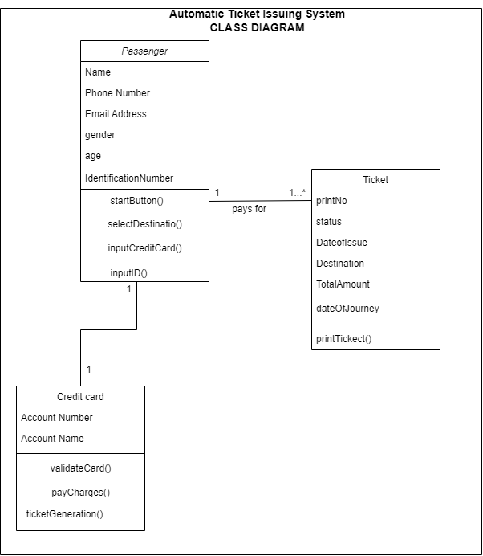

## USE CASE DIAGRAM

The use case diagram presented below illustrates clears how many users we have/interact with the system, the role of each user in the system. Its clear that Passengers role is to get to the system, press start button, select his/her destination of choice. Make payments by imputing the credit card. The identification number the Passenger inputs is meant for recognition of unique passengers making payments in the system. The system on the other hand is meant for responding to the user inputs in order to later generated the ticket whenever the process goes successful.

